 | 奧 冠 教 育 中 心  OLYMPIAD CHAMPION EDUCATION CENTRE  Room 309-310, 8 Jordan Road, Yau Ma Tei, Kowloon, Hong Kong SAR, CHINA  Tel (852) 3153 2028 / 9310 1240 Fax (852) 3153 2074  Website: www.olympiadchampion.com Email: olympiadchampion@gmail.com


香港國際科學競賽初賽2019 - 2020（香港賽區）
Hong Kong International
Science Olympiad
Heat Round 2019 - 2020 (Hong Kong Region)

中一級Secondary 1
時限：60分鐘
Time allowed: 60 minutes
模擬試題
Mock Paper
考生須知：
Instructions to Contestants:
1. 本卷包括 試題 乙份，試題紙不可取走。
Each contestant should have ONE Question-Answer Book which CANNOT be taken away.
2. 本卷共4個範疇，每範疇有5題，共20題，答對得2分，空題得0分，答錯倒扣1分。
There are 4 exam areas and 5 questions in each exam area. There are a total of 20 questions in this Question-Answer Book. Two points for correct answers. No points for incorrect answers. ONE penalty point will be deducted for incorrect answers.
3. 請將答案寫在 答題紙 上。
All answers should be written on ANSWER SHEET.
4. 比賽期間，小學組不得使用計算工具，中學組可以使用計算工具。
During the contest, NO calculators can be used for PRIMARY GROUP but calculators can be used for SECONDARY GROUP.
5. 本卷中所有圖形不一定依比例繪成。
All figures in the paper are not necessarily drawn to scale.
6. 比賽完畢時，本試題會被收回。
This Question-Answer Book will be collected at the end of the contest.
本試題不可取走。
THIS Question-Answer Book CANNOT BE TAKEN AWAY.
未得監考官同意，切勿翻閱試題，否則參賽者將有可能被取消資格。
DO NOT turn over this Question-Answer Book without approval of the examiner.
Otherwise, contestant may be DISQUALIFIED.
選擇題（第1至20題）（答對得2分，空題得0分，答錯倒扣1分）
Multiple Choice Questions (1st ~20th) (Two points for correct answers. No points for incorrect answers. ONE penalty point will be deducted for incorrect answers.)

Physics
物理

1. Which among the following numbers is the largest?
A. The number of air molecules in a 3 m × 3 m × 3 m classroom.
B. The number of water molecules in a one-litre bottle filled with water.
C. The number of breaths you have taken since your birth.
D. The number of seconds which have passed since the origin of the Universe.
E. All of the above

2. Playing with a lens one morning, Rita discovers that if she holds the lens 0.120 m away from a wall opposite to a window, she can see a sharp but upside-down picture of the outside world on the wall. That evening, she covers a lighted lamp with a piece of card on which she has pierced a small hole, 0.005 m in diameter. By placing the lens between the illuminated card and the wall, she manages to produce a sharp image of diameter 0.020 m on the wall.

What is the distance between the card and the wall?
A. 0.450 m
B. 0.750 m
C. 0.600 m
D. 0.300 m
E. Cannot be calculated

3. Equal amounts of ice at 00 C are placed in three containers P, Q and R, which are kept in a constant temperature environment. Identical heating elements are placed inside each container. These heating elements are powered with different voltages: 100 V, 200 V and 300 V in containers P, Q and R, respectively. It was found that it took 20 minutes to melt all the ice in container Q, and it took 4 minutes to melt all the ice in container R. Assuming that at any instant heat is uniformly dissipated in each container throughout its volume, which of the following is correct?

A. It will take (approximately) 80 min to melt all the ice in container P.
B. It will take (approximately) 100 min to melt all the ice in container P.
C. It will take (approximately) 132 min to melt all the ice in container P.
D. It will not be possible to melt all the ice in container P with the given power source.
E. None of the above

4. Two conducting circular loops F and G are kept in a plane on either side of a straight currentcarrying wire as shown in the figure below.
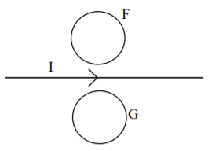
If the current in the wire decreases in magnitude, the induced current in the loops will be
A. clockwise in F and clockwise in G.
B. anti-clockwise in F and clockwise in G.
C. clockwise in F and anti-clockwise in G.
D. anti-clockwise in F and anti-clockwise in G.
E. none of the above

5. An opaque hemisphere of radius R lies on a horizontal plane as shown in the figure below.
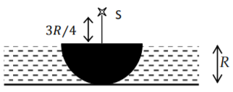
On the perpendicular through the point of contact, a point source of light S is placed at a distance above the centre of the hemisphere. A transparent liquid of refractive index is filled above the plane such that the hemisphere is just covered with the liquid. The area of the shadow on the horizontal plane is

A. B. C. D. E. Cannot be calculated

Biology
生物

6. Nucleic acids can be double stranded (ds) or single stranded (ss). The following table gives the composition of bases in four different nucleic acid samples.
 | Amount of base (%)
 | A | T | G | C | U
Sample 1 | 40 | 40 | 10 | 10 | 0
Sample 2 | 10 | 40 | 40 | 10 | 0
Sample 3 | 40 | 0 | 40 | 10 | 10
Sample 4 | 40 | 0 | 20 | 10 | 30

Using the information given above, it may be deduced that the samples 1, 2, 3, 4 are
A. 1 : dsDNA, 2 : ssDNA, 3 : ssRNA, 4 : ssRNA.
B. 1 : dsDNA, 2 : ssRNA, 3 : dsDNA, 4 : ssDNA.
C. 1 : ssDNA, 2 : dsDNA, 3 : ssRNA, 4 : dsRNA.
D. 1 : dsDNA, 2 : ssRNA, 3 : ssDNA, 4 : ssDNA
E. None of the above

7. The following is the pedigree of a family from a marriage between first cousins. Males are represented by squares and females by circles. The family has a very rare X-linked trait. Out of their progeny individuals 1, 2, 3 in the figure), individual 3, who expressed this trait, married outside the family to individual 4, who is not a carrier of this trait.
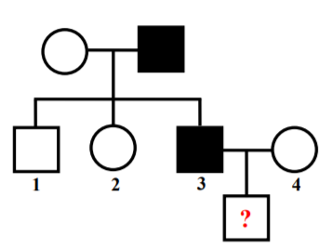
Consider the following statements regarding the above trait:
(i) The trait is recessive.
(ii) The trait is dominant.
(iii) The probability that the daughter (individual 2) is a carrier is 0.
(iv) The probability that the daughter (individual 2) is a carrier is 1.
(v) The probability that a son born to individuals 3 and 4 will express the trait is 0.
(vi) The probability that a son born to individuals 3 and 4 will express the trait is 0.5.

Which of the above statements are correct?
A. (i), (iii) and (vi)
B. (i), (iv) and (v)
C. (ii), (iii) and (vi)
D. (ii), (iv) and (v)
E. None of the above

8. DNA replicates in a semi-conservative manner in which each individual strand is copied to form a new molecule of DNA. The two strands can be labelled with isotopes using substrates that contain either normal or its heavy isotope . In an experiment, one strand of DNA was labelled with and the other with (hybrid DNA). The hybrid DNA was then allowed to replicate in the presence of the -labelled substrate. If one started with a single molecule of hybrid DNA and allowed it to replicate over 4 cycles, what would be the proportion of double-stranded DNA molecules labelled with ?
A. B. C. D. E.
9. Assimilation of by photosynthesis in cacti growing in arid regions occurs in two stages. In stage 1, uptake and fixation occurs at night and is stored in the form of malate in vacuoles. In stage 2, during the day the malate moves to the chloroplast where it is decarboxylated, and the released is re-fixed by RuBP carboxylase. The main reason for this is:

A. Cacti require light for RuBP carboxylase activity.
B. Cacti close their stomata during the day, so availability of for RuBP carboxylase activity is low during the day.
C. Cacti can fix only at an acidic pH that is provided by malate.
D. Cacti have chloroplasts that are impermeable to but are permeable to malate.
E. None of the above

10. In an eukaryotic cell, mitochondria and chloroplasts are thought to have originated through endosymbiosis, a process in which an organism engulfs another and the two continue to exist in a mutually beneficial arrangement. Which of the following observations best supports this theory?

A. These organelles exchange metabolites with other cellular compartments.
B. These organelles are capable of independent existence outside the cell.
C. These organelles have their own genetic material.
D. These organelles provide energy in the form of ATP to the cell.
E. None of the above

Chemistry
化學

11. Consider an element with 7 electrons. In the ground state, these electrons may be arranged in 1s, 2s and 2p orbitals in four different ways
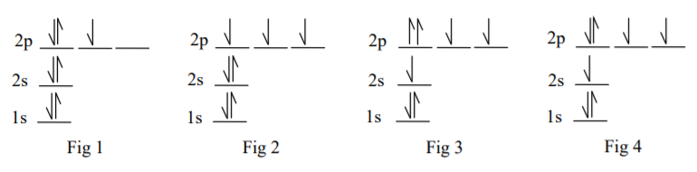
Choose the CORRECT statement from the following.
A. Fig 4 and Fig 2 are correct..
B. Only Fig 2 is correct.
C. Only Fig 1 is correct.
D. Fig 3 and Fig 4 are correct.
E. None of the above

12. A glass pipe is connected on either side to gas reservoirs, one containing HCl gas at normal temperature and pressure (NTP) and the other containing NH3 gas, also at NTP. X and Y are two stop-cocks, separated by 2.00 m, which, when closed, prevent the flow of gas into the glass pipe.
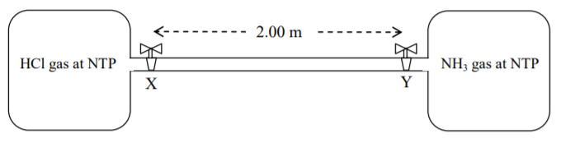
It was observed that when the stop-cocks X and Y were opened simultaneously, then white fumes first appeared at a point P inside the glass pipe between X and Y. The distance of the point P from the stop-cock X is nearly
A. 1.00 m B. 1.19 m C. 0.81 m D. 0.62 m E. Cannot be calculated

13. The phase diagram (pressure against temperature) for a substance S is given below.
Consider the following statements for the substance S:
(i) At point 1, solid S can spontaneously convert to gaseous S but not to liquid S.
(ii) At point 2, liquid S can be in equilibrium with gaseous S.
(iii) At point 3, liquid S can start boiling to gaseous S.
(iv) At point 4, S is in liquid state.
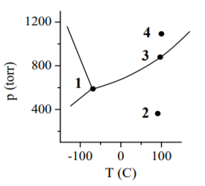
Which of the following is correct for the substance S?
A. Statements (ii) and (iv) are correct.
B. Statements (i) and (ii) are correct.
C. Statements (i) and (iii) are correct.
D. Statements (iii) and (iv) are correct.
E. None of the above

14. In the pharmaceutical industry, a chemical analysis of aspirin involves the following reaction
In one such analysis it was found that the rate of formation of at a particular instant was 0.25 mol s. This indicates that the rate of disappearance of (in mol s) would be

A. 0.50 B. 0.42 C. 0.15 D. 0.83 E. Cannot be calculated

15. Corrosion of iron pipes occurs in the presence of water. To prevent such corrosion, iron pipes are normally coated with an element like magnesium using electroplating. Which of the following statements is correct?

A. During corrosion of an un-plated iron pipe, water is oxidized;
During electroplating, iron acts as anode.
B. During corrosion of an un-plated iron pipe, oxygen is reduced;
During electroplating, iron acts as cathode.
C. During corrosion of an un-plated iron pipe, iron is oxidised;
During electroplating, magnesium is deposited on the anode.
D. During corrosion of an un-plated iron pipe, iron is reduced;
During electroplating, magnesium is deposited on the cathode.
E. None of the above

Integrated Science
綜合科學

16. The figure below shows a glass flask whose hemispherical base is of diameter 0.20 m. The height of the flask is 0.25 m. The flask is filled to the brim with 2.5 litres (1 litre =) of water and sealed with a glass lid.
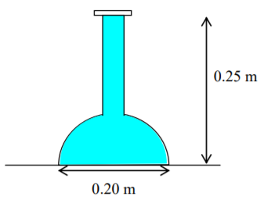
What is the approximate magnitude of the total vertical force exerted by the water on the curved surface of the flask? (Take the acceleration due to gravity, g, to be 10 ).
A. 0 N B. 78.5 N C. 53.5 N D. 25.0 N E. Cannot be calculated

17. Consider the three molecules , and . Which of the statements below is INCORRECT?
A. Each of the 3 molecules has a pair of unshared valence electrons.
B. Each of the molecules is polar.
C. Each of the molecules contains three sigma bonds.
D. Each of the molecules is planar and triangular.
E. All of the above

18. The solubility product of is at room temperature. If 50 ml of 0.02 M are mixed with 50 ml of 0.01 M , then
A. will precipitate and excess will remain in solution.
B. will precipitate.
C. will precipitate and excess will remain in solution.
D. no precipitate will form.
E. all of the above is correct.

19. Charles Darwin observed that seedlings grow towards light. He called this response phototropism.’ In an experiment two light sources are used to illuminate each seedling. Each source is indicated by a yellow circle in the diagrams below. The larger yellow circle represents a light source with twice the illumination than the light source represented by the smaller yellow circle.
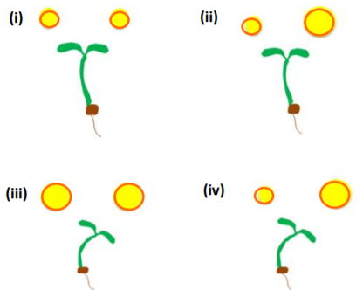
Which of the above responses would be observed?
A. only (iv)
B. only (ii)
C. (i) and (iii)
D. (i) and (iv)
E. (i), (ii) and (iii)
20. Ammonia, urea and uric acids are toxic, nitrogenous waste products produced by break down of protein and nucleic acids. These waste products have to be excreted. Ammonia is highly toxic and has a high solubility in water. Urea is less soluble and less toxic than ammonia. Uric acid is least toxic and has low solubility. Excretion of nitrogenous waste from a frog and a tadpole would primarily be as

A. Urea in tadpole and ammonia in frog.
B. Ammonia in tadpole and urea in frog.
C. Urea in both tadpole and frog.
D. Uric acid in tadpole and urea in frog.
E. All of above is correct.

~ 全卷完 ~
~ End of Paper ~

